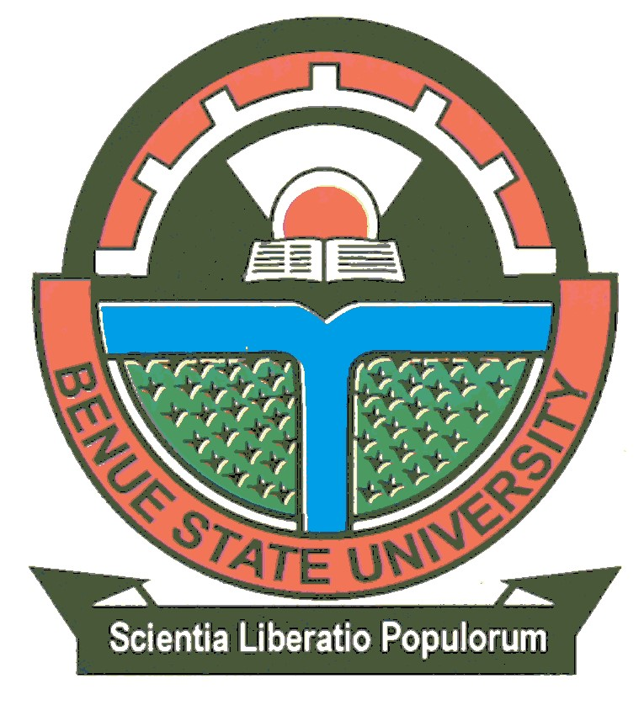

**BENUE STATE UNIVERSITY, MAKURDI**

6th February, 2023

**PRESS RELEASE**

**18TH-21ST COMBINED CONVOCATION CEREMONIES AND 30TH ANNIVERSARY CELEBRATION**

The Vice-Chancellor, Benue State University, Makurdi, **Professor Tor Joe Iorapuu, fsonta, ksm, mnipr** on behalf of the Council, Management, Senate, Staff and Students, invites Parents, Guardians and Graduands (2015/2016-2018/2019**)** to the **18th –21st Combined Convocation Ceremonies** of the University. First Degrees, Postgraduate Diplomas, Higher Degrees and Honorary Doctorate Degrees shall be conferred on deserving persons at this event.

Highlights of the Convocation Ceremonies are:

|  |  |  |  |  |  |
| --- | --- | --- | --- | --- | --- |
| **S/NO** | **DATE** |  | **TIME** | **ACTIVITY** | **VENUE** |
| 1 | Wednesday,  February, 2023 | 15th | 9:00am | Football Match between Female Students of Eastern and Western Wing | Football Pitch, Eastern Wing |
| 4:00pm | Football Match between Male Students of Eastern and Western Wing | Football Pitch,  Eastern Wing |
| 2 | Thursday,  February, 2023 | 16th | 9:00am | Vice-Chancellor’s Opening of Free Health Care for All Staff | BSU Clinic |
| 10:00am | Vice-Chancellor’s Convocation Press Briefing | Senate Chamber |
| 5:00pm | Novelty Football Match Between Management and BSU Alumni  Myschoooltrick.com | Football Pitch, Eastern Wing |
| 3 | Friday, 17th February, 2023 |  | 2:00pm | Convocation & Memorial Lecture in honour of late Rev.Fr Moses Orshio Adasu (Pioneer Visitor).  v Recognition of some pioneer Staff and Students  Topic: Embracing Change and Building  Resilience through Innovation: The Role of  Universities  **Lecturer:** Professor Terhemba Wuam (Pioneer Alumnus) Dean, Students Affairs, Kaduna State University, Kaduna | Auditorium 1,  College of Health Sciences, Benue State University,  Makurdi |
| 5:00pm | Convocation Play | Theatre Arts Complex |
| 7:00pm | Vice-Chancellor’s Dinner | Auditorium 1,  College of Health Sciences, Benue State University,  Makurdi |
| 4 | Saturday, 18th  February, 2023  Myschoooltrick.com | | 10:00am | 1. Installation of the New Chancellor, HGM (Barr.) King Disrael Gbobo Bob-Manuel   (II) KSC, JP, UN-MP, DSSRS Ekineye  Gbobo (I), Owukori (IX)   1. Conferment of First Degrees,   Postgraduate Diplomas, Higher Degrees and Honorary Degrees   1. Award of Prizes | New Convocation  Square |
| 5 | Sunday, 19th February, 2023 | | 8:00am | Special Thanksgiving Mass  Myschoooltrick.com | Good Shepherd  Catholic  Chaplaincy |

**Honorary Doctorate Degree Recipients:**

Some eminent Nigerians will be conferred with honorary Doctorate degrees

# NOTICE TO ALL GRADUANDS

Graduands are to note that Academic Gowns and Order of Proceedings will be available for collection on payment of a prescribed fee from the Secretary, Postgraduate School; Secretary, Centre for Food Technology and Research (CEFTER); Secretary, Sandwich Unit and Faculty Officers on first come first served basis, from ***Monday, 13th February, 2023.***

All Academic gowns must be returned at the close of the Convocation Ceremonies on or before Tuesday, 21st February, 2023. Late submission shall attract a surcharge of **N200.00** for each day of default.

# Sgd Dr. Mrs. Mfaga Modom, *MNIM*

Registrar/Secretary to Council